Arguments with All, None, Some

Example 1
All teachers are honest
All honest people like sprouts
So all teachers like sprouts
This argument consists of two premises and a conclusion:
Premise: All teachers are honest
Premise: All honest people like sprouts
Conclusion: All teachers like sprouts
We are not interested in whether the premises are true or false. We are interested in whether the argument is valid or invalid. An argument is only valid if the conclusion must be true whenever both the premises are true. We can use a Venn diagram to decide if an argument is valid or invalid.
We have a rectangular room and there are three loops drawn on the floor.
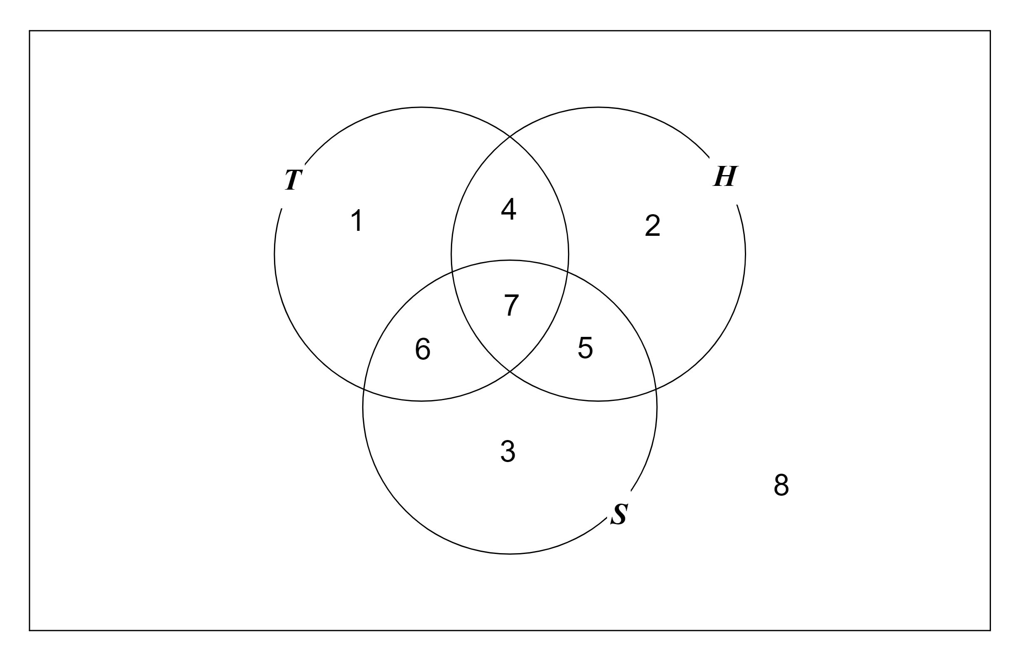

Everyone is standing somewhere in the room. Teachers must stand inside the T loop. Honest people must stand inside the H loop. People who like sprouts must stand inside the S loop.
People standing inside region 1 are teachers, not honest, do not like sprouts
People standing inside region 5 are not teachers, honest, do like sprouts
People standing inside region 7 are teachers, honest, do like sprouts
etc
Premise: All teachers are honest
This means there is no-one standing in regions 1 or 6. So we put a cross in each of these regions.
Premise: All honest people like sprouts
This means there is no-one standing in regions 2 or 4. So we put a cross in each of these regions.

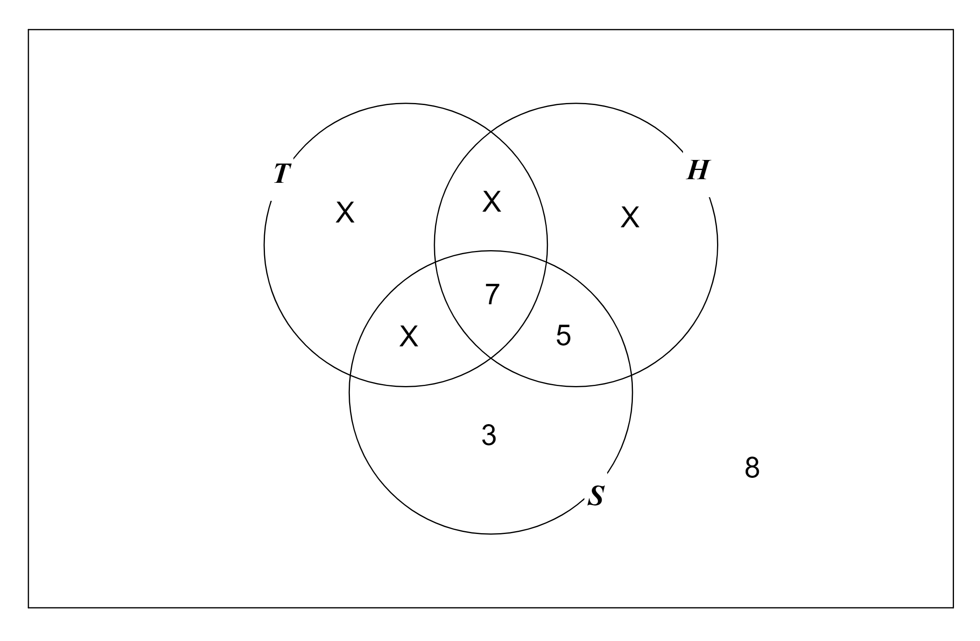

Conclusion: All teachers like sprouts
This means there should be crosses in regions 1 and 4. Yes!
So if both premises are true then the conclusion must be true. So the argument is valid.
We are not really interested in teachers, honest people and people who like sprouts. We are interested in the form of the argument. We could say:
All A are B
All B are C
So all A are C
This argument form is valid. So any argument of this form is valid, such as:
All lawyers are happy
All happy people like Beethoven
So all lawyers like Beethoven

Example 2
All A are B
No C are A
So no C are B
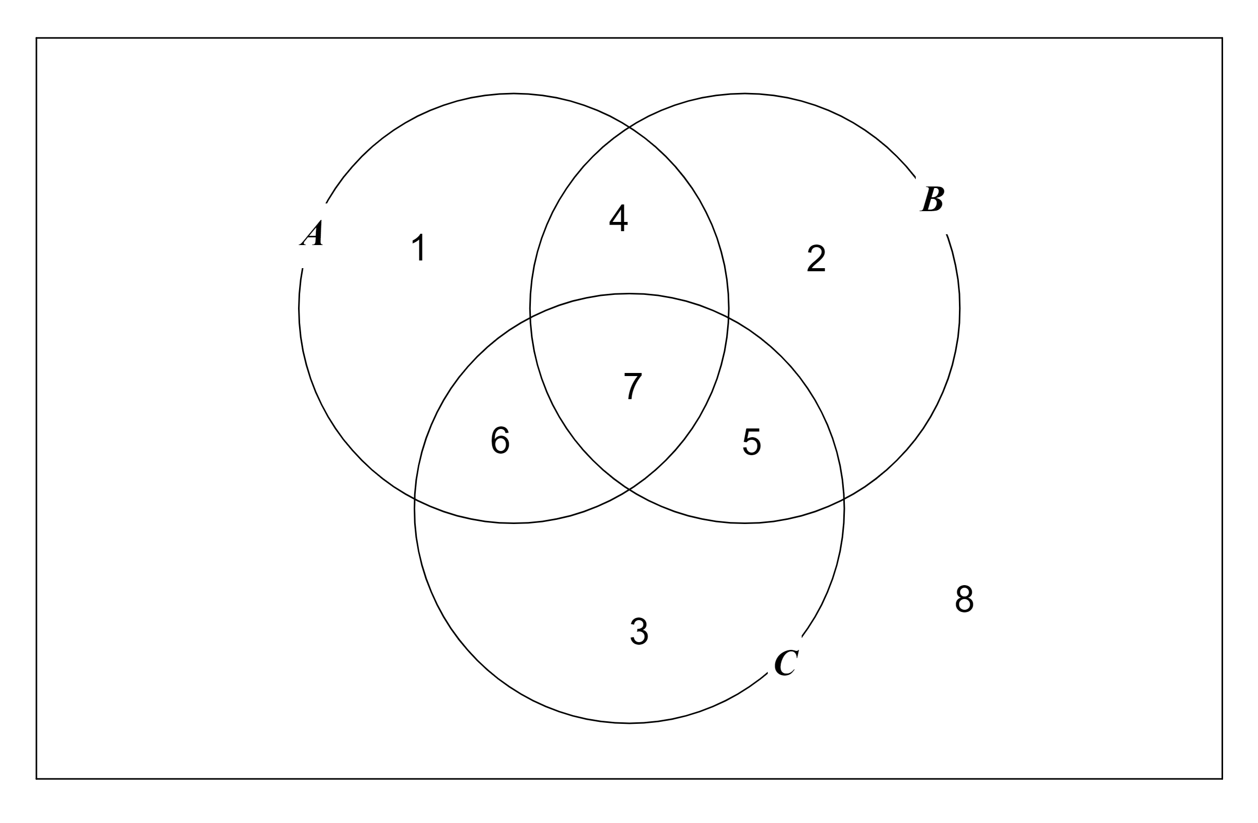

Premise: All A are B
This means there is no-one standing in regions 1 or 6
Premise: No C are A
This means there is no-one standing in regions 6 or 7

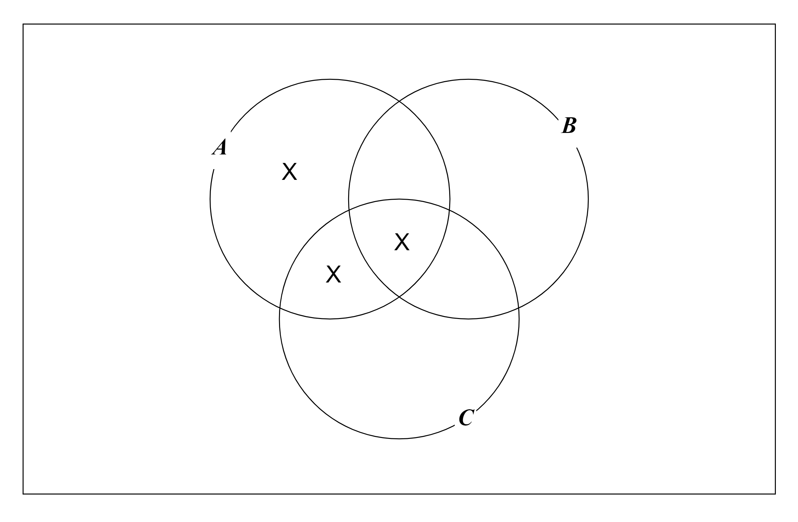

Conclusion: No C are B
This means there should be crosses in regions 5 and 7. No!
So the argument is invalid. So any argument of this form is invalid, such as:
All dentists are polite.
No hoodlums are dentists.
So no hoodlums are polite.

Example 3
All teachers are honest
Some teachers like sprouts
So some honest people like sprouts

All teachers are honest we put a cross in regions 1 and 6
Some teachers like sprouts this means that there is at least one teacher who likes sprouts, so there is at least one person in region 6 or 7, so we put question-marks in regions 6 and 7

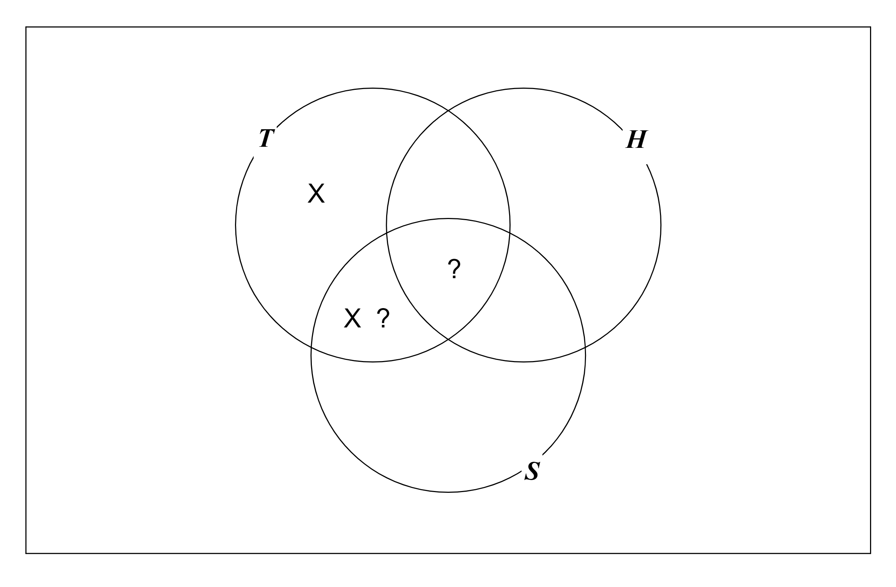

Conclusion: Some honest people like sprouts
There is at least one person in region 6 or 7, but there is no-one in region 6 (because region 6 has a cross), so there must be at least one person in region 7, so there must be at least one person who is honest and likes sprouts, so some honest people like sprouts, so the argument is valid.

Example 4
All A are B
Some B are C
So some A are C

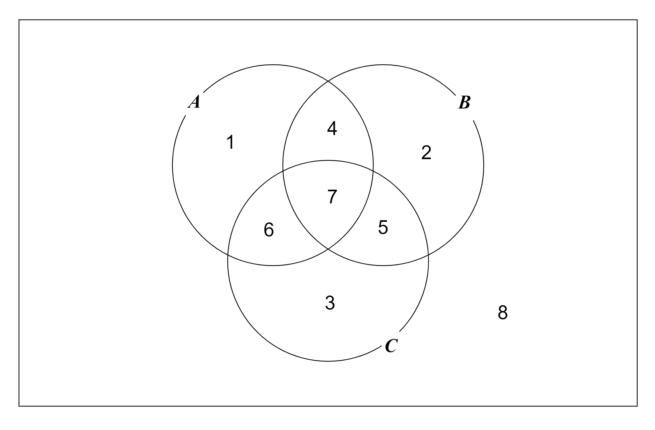

All A are B put crosses in regions 1 and 6
Some B are C put question-marks in regions 5 and 7

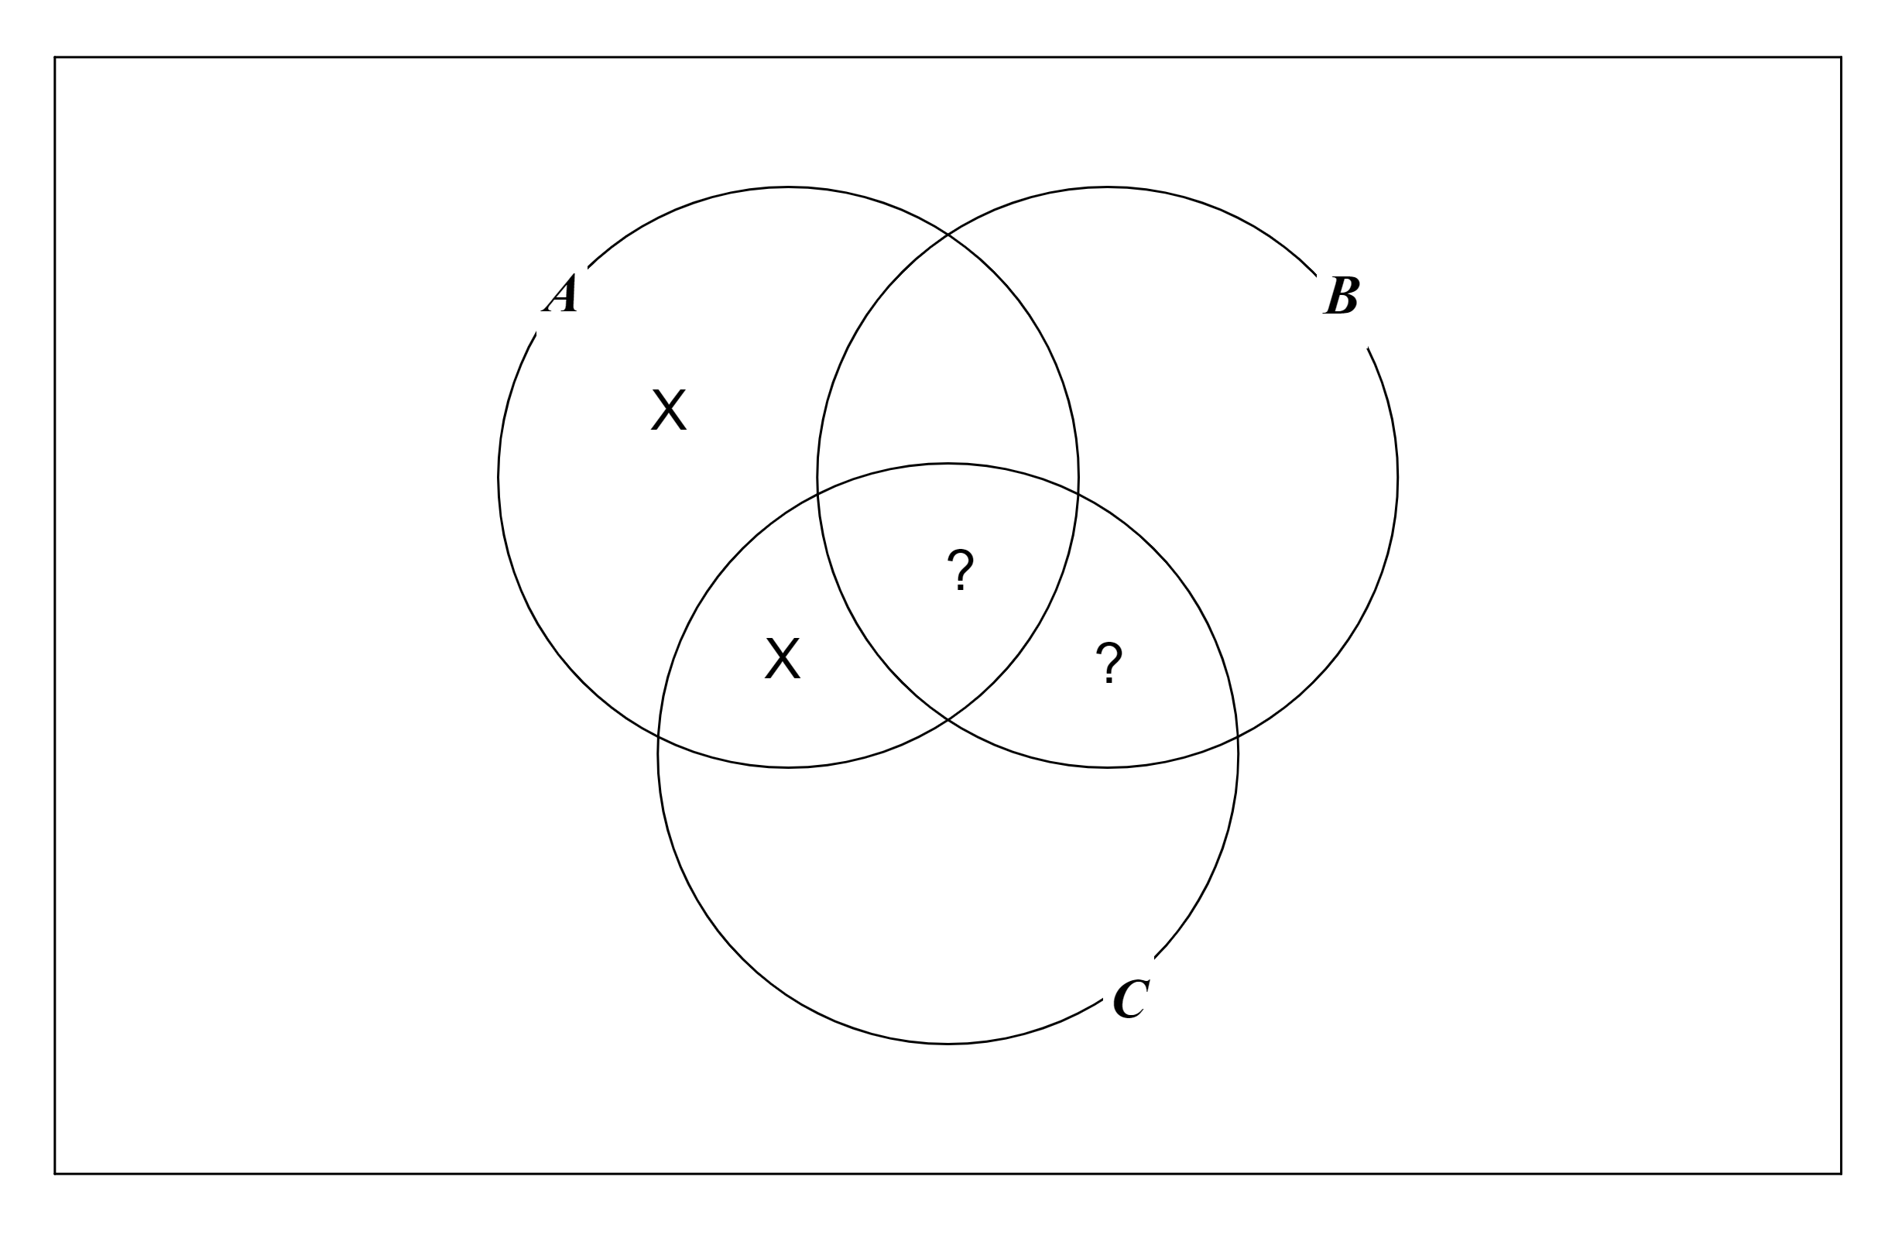

Conclusion: Some A are C
There is at least one person in region 5 or 7, but we cannot be certain that there is anybody in region 7
So the argument is invalid. So any argument of this form is invalid, such as:
All cats are mammals.
Some mammals are ferocious.
So some cats are ferocious.

Example 5
Some A are B
Some B are C
So some A are C

Some A are B put question-marks in regions 4 and 7
Some B are C we cannot just put question-marks in regions 5 and 7 because we will get these mixed up with the question-marks from Some A are B, so we will use asterisks instead

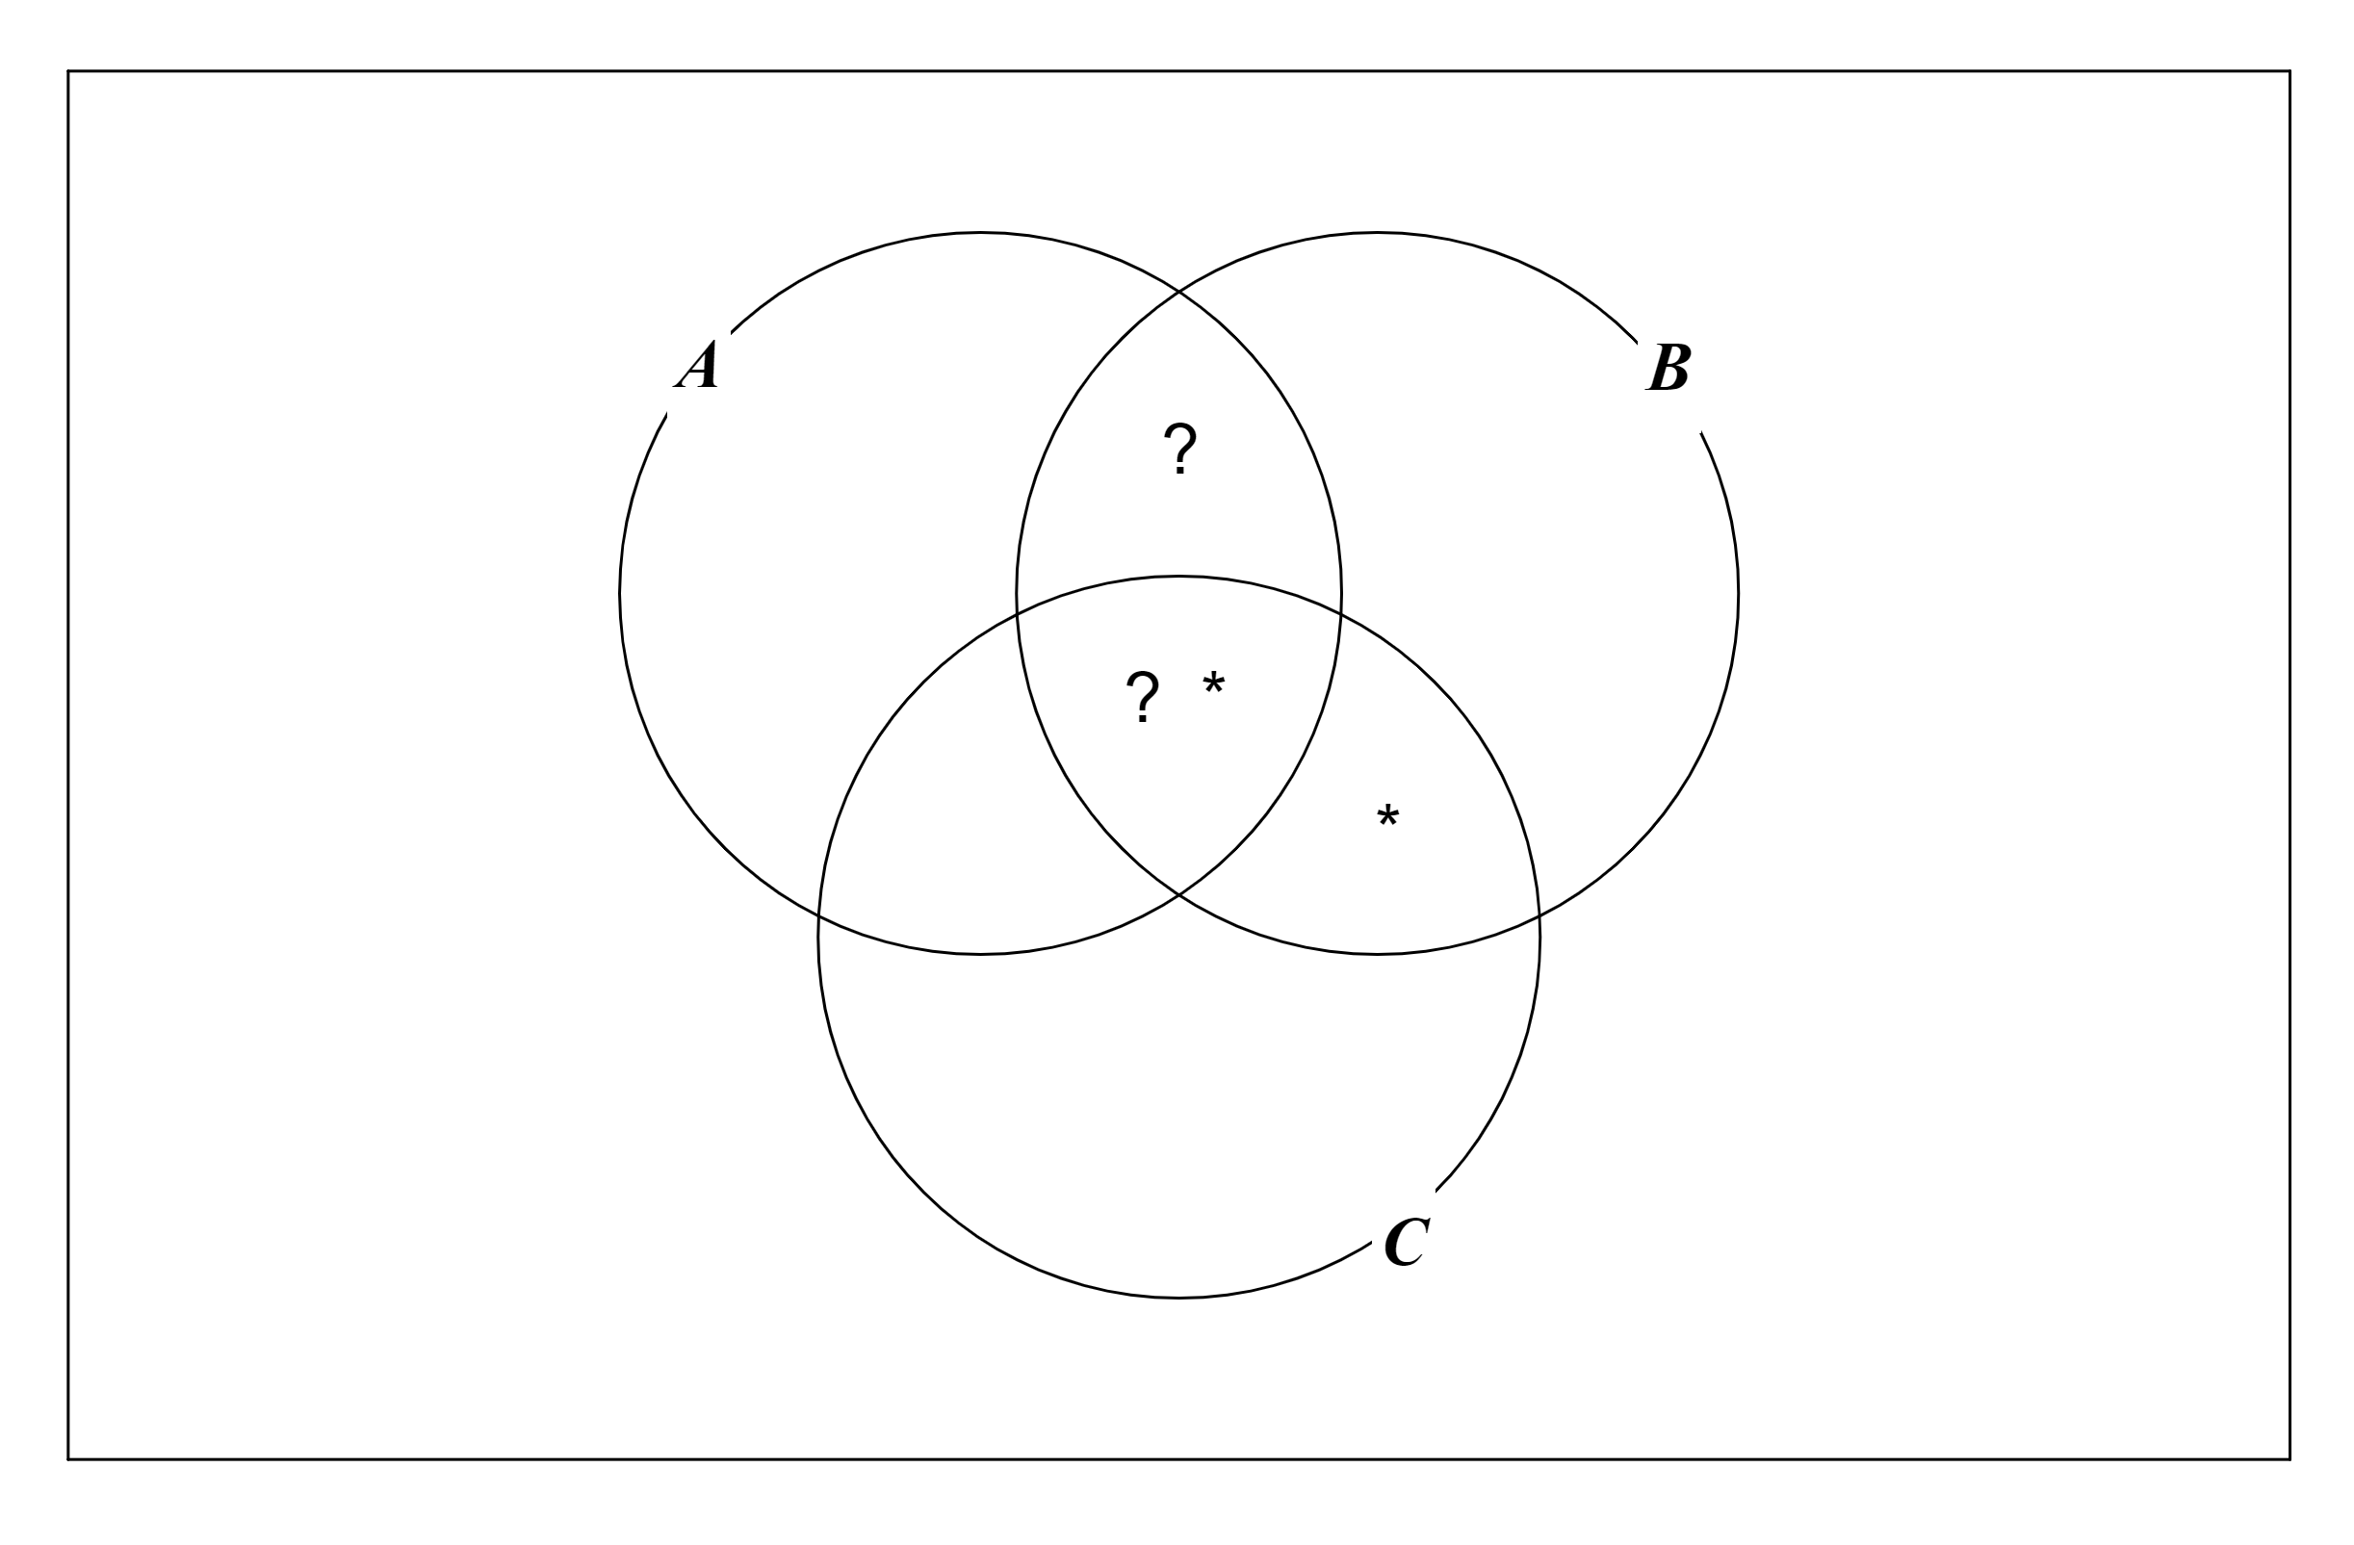

Conclusion Some A are C
There is at least one person in regions 4 or 7 and there is at least one person in regions 5 or 7, but we cannot be certain that there is anybody in region 7
So the argument is invalid.

In fact, if our two premisses both begin with Some … then the argument will always be invalid.
Think about it!

EXERCISE
Show that these two arguments are invalid:
1. All A are B
All C are B
So all C are A
2. All A are B
All A are C
So all C are B
Now try these:
3. No bankers are poor.
No poor people eat carrots.
So all bankers eat carrots.
4. All plumbers are rich.
No rich people are happy.
So no plumbers are happy.
5. No dentists eat sugar.
All communists eat sugar.
So no dentists are communists.
6. All astronauts are handsome.
All handsome people like jazz.
So all astronauts like jazz.
7. Some teachers eat bananas.
All teachers like spaghetti.
So some people who like spaghetti eat bananas.
8. No A are B
Some B are C
So no A are C
9. All A are B
Some C are B
So some A are C
10. The negation of:
it is raining
is:
it is not raining
Write down the negations of the following:
a) All astronauts like jazz
b) No astronauts like jazz
c) Some astronauts like jazz
d) All A are B
e) No A are B
f) Some A are B
g) Some A are not B
11. Only A are B All B are A
Do these mean the same thing?

SOLUTIONS
1. invalid
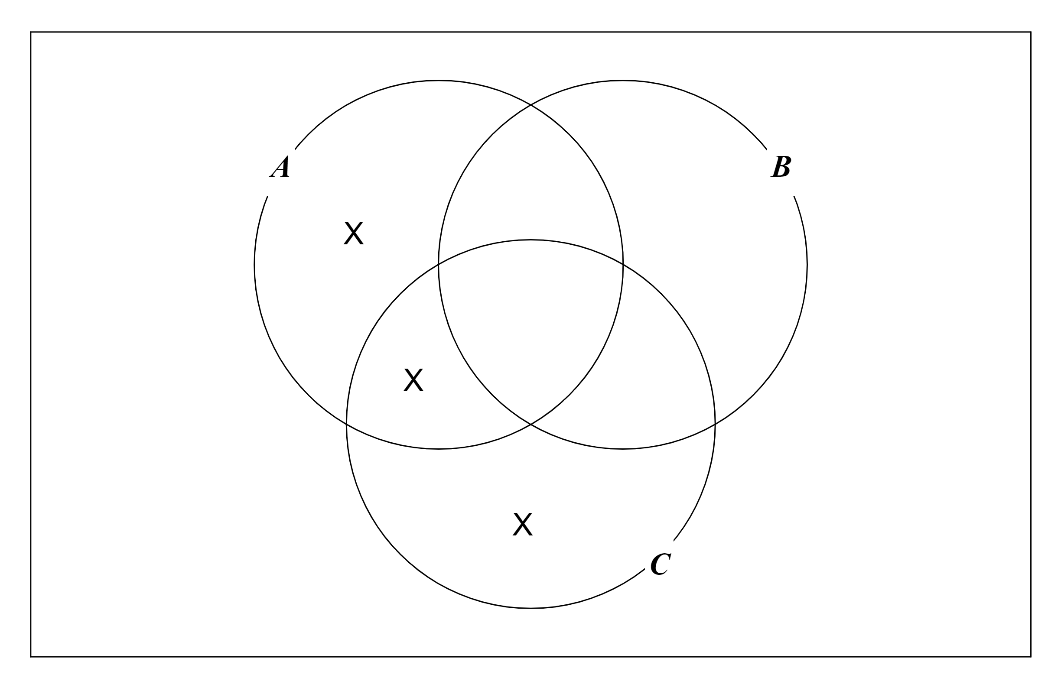

2. invalid
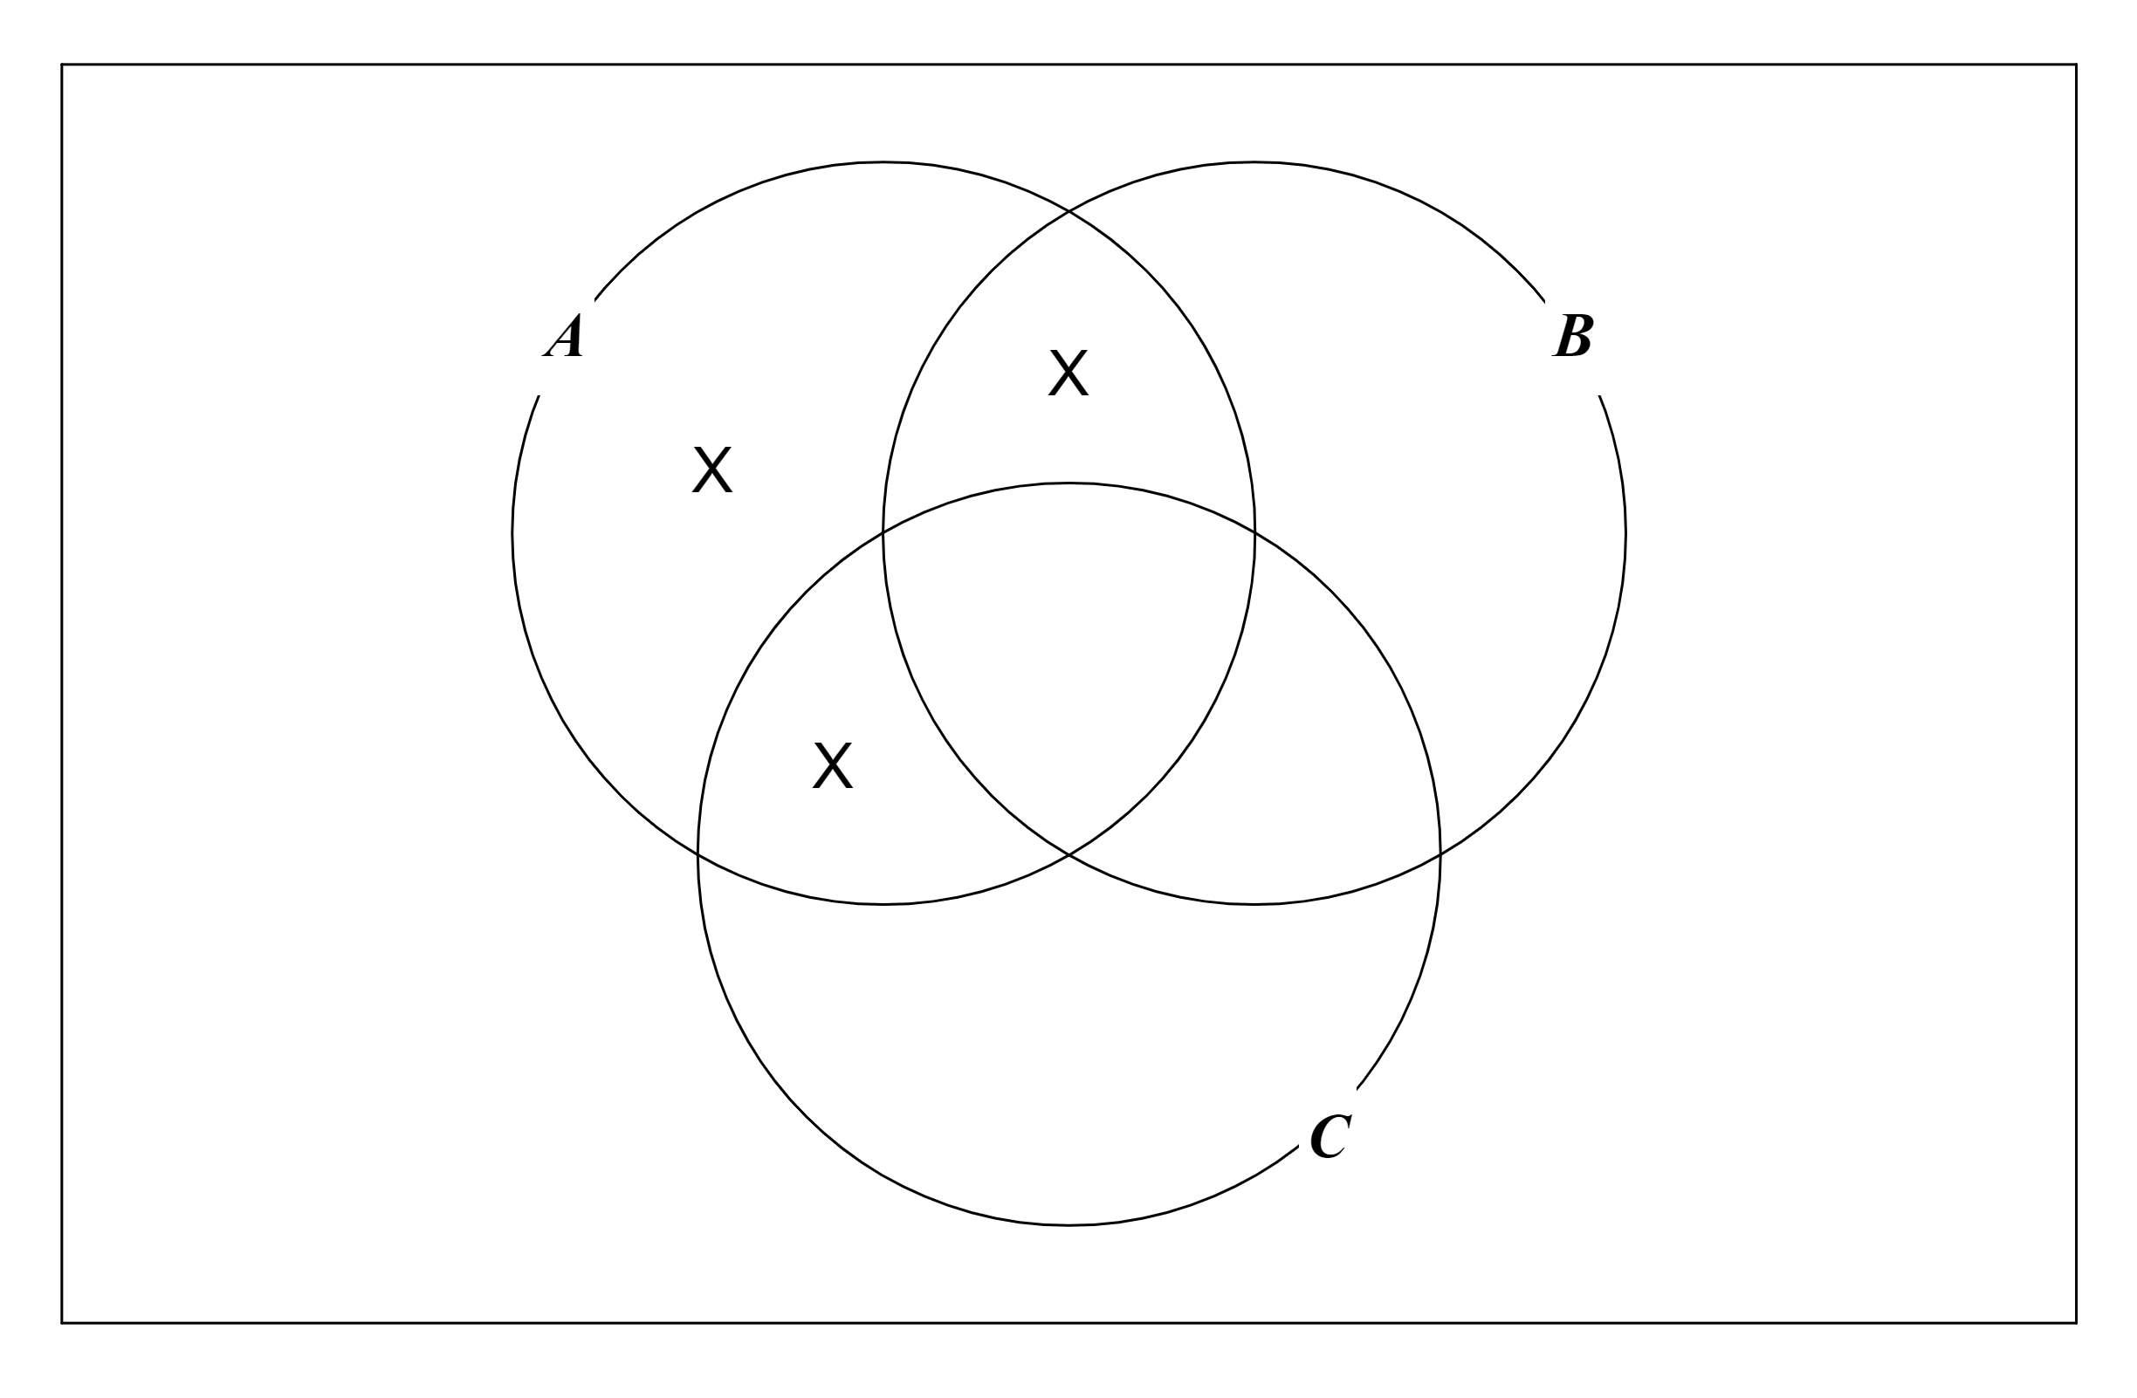

3. invalid
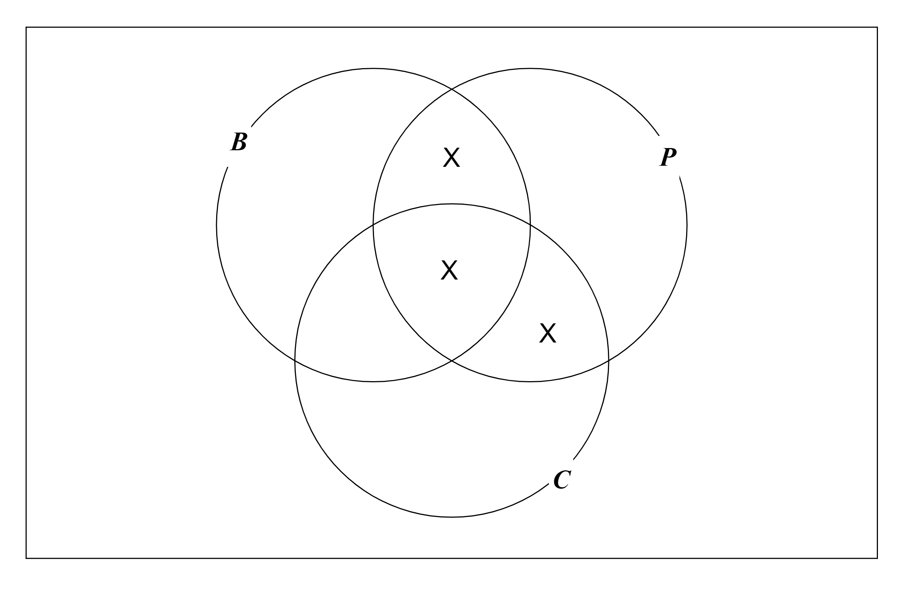

4. valid
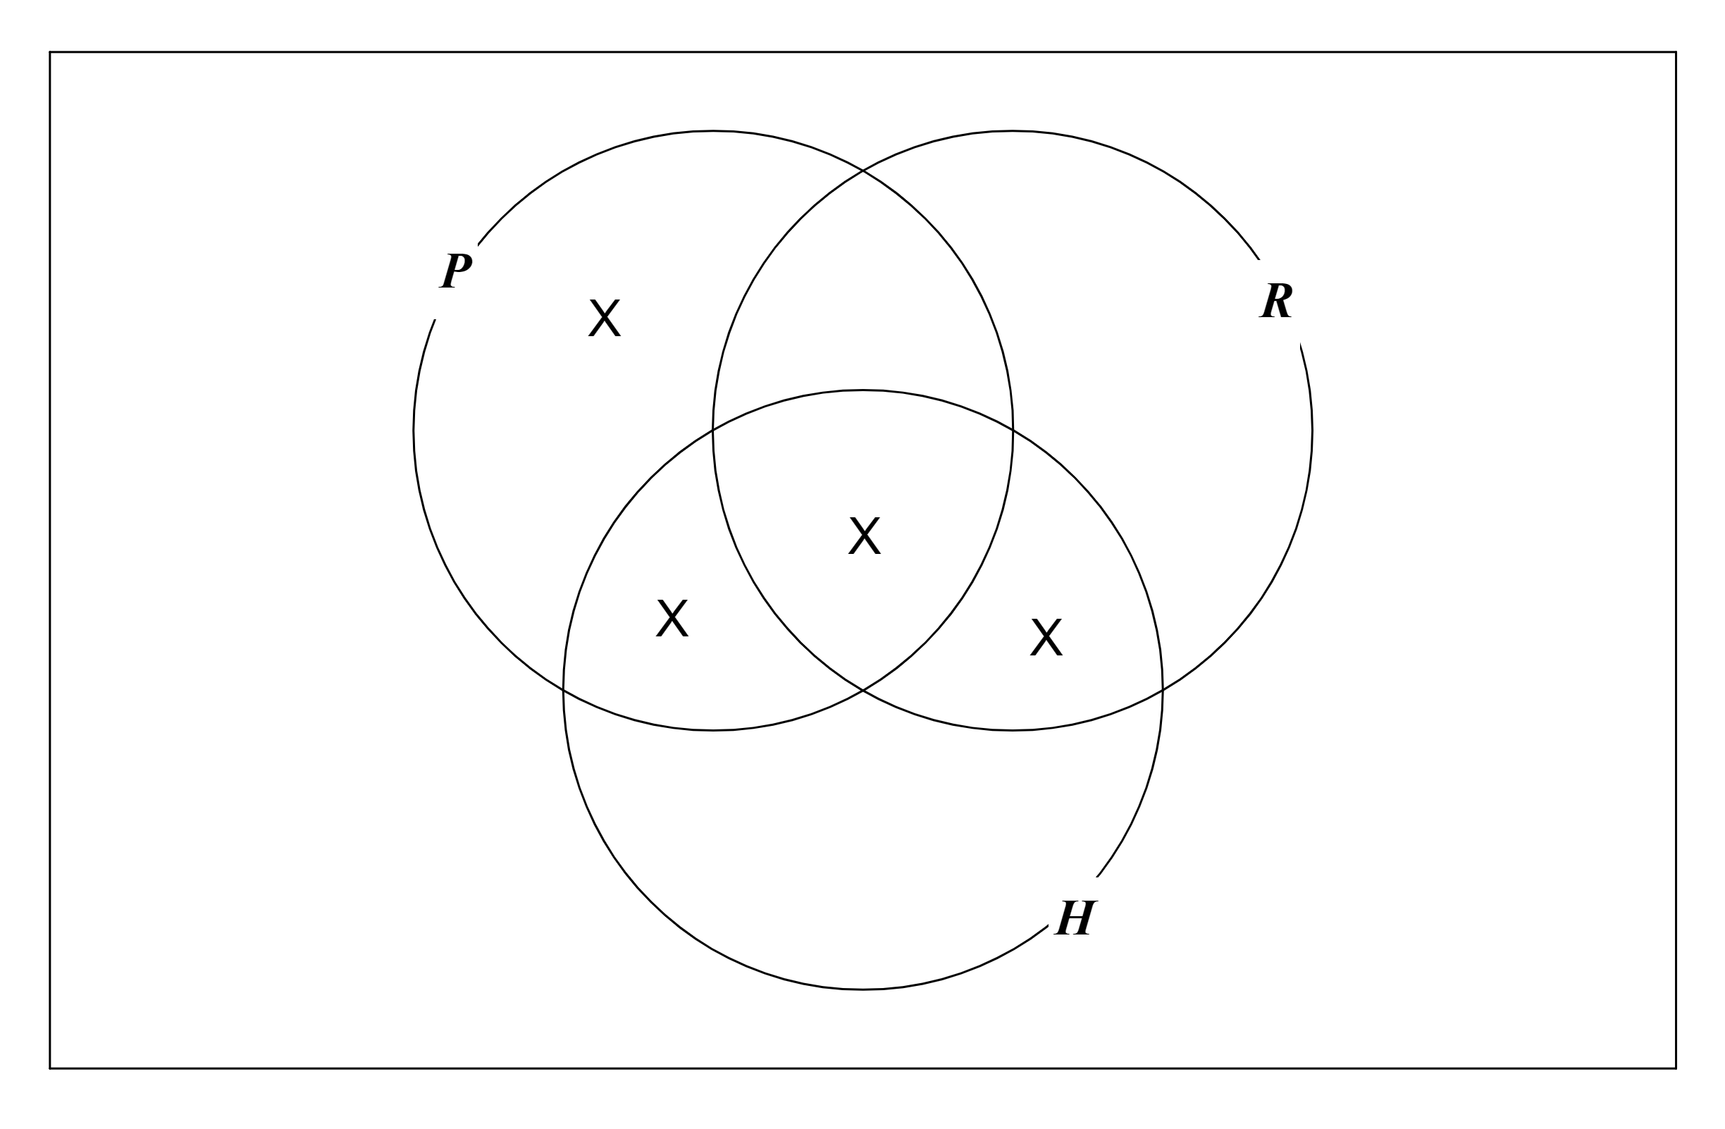

5. valid
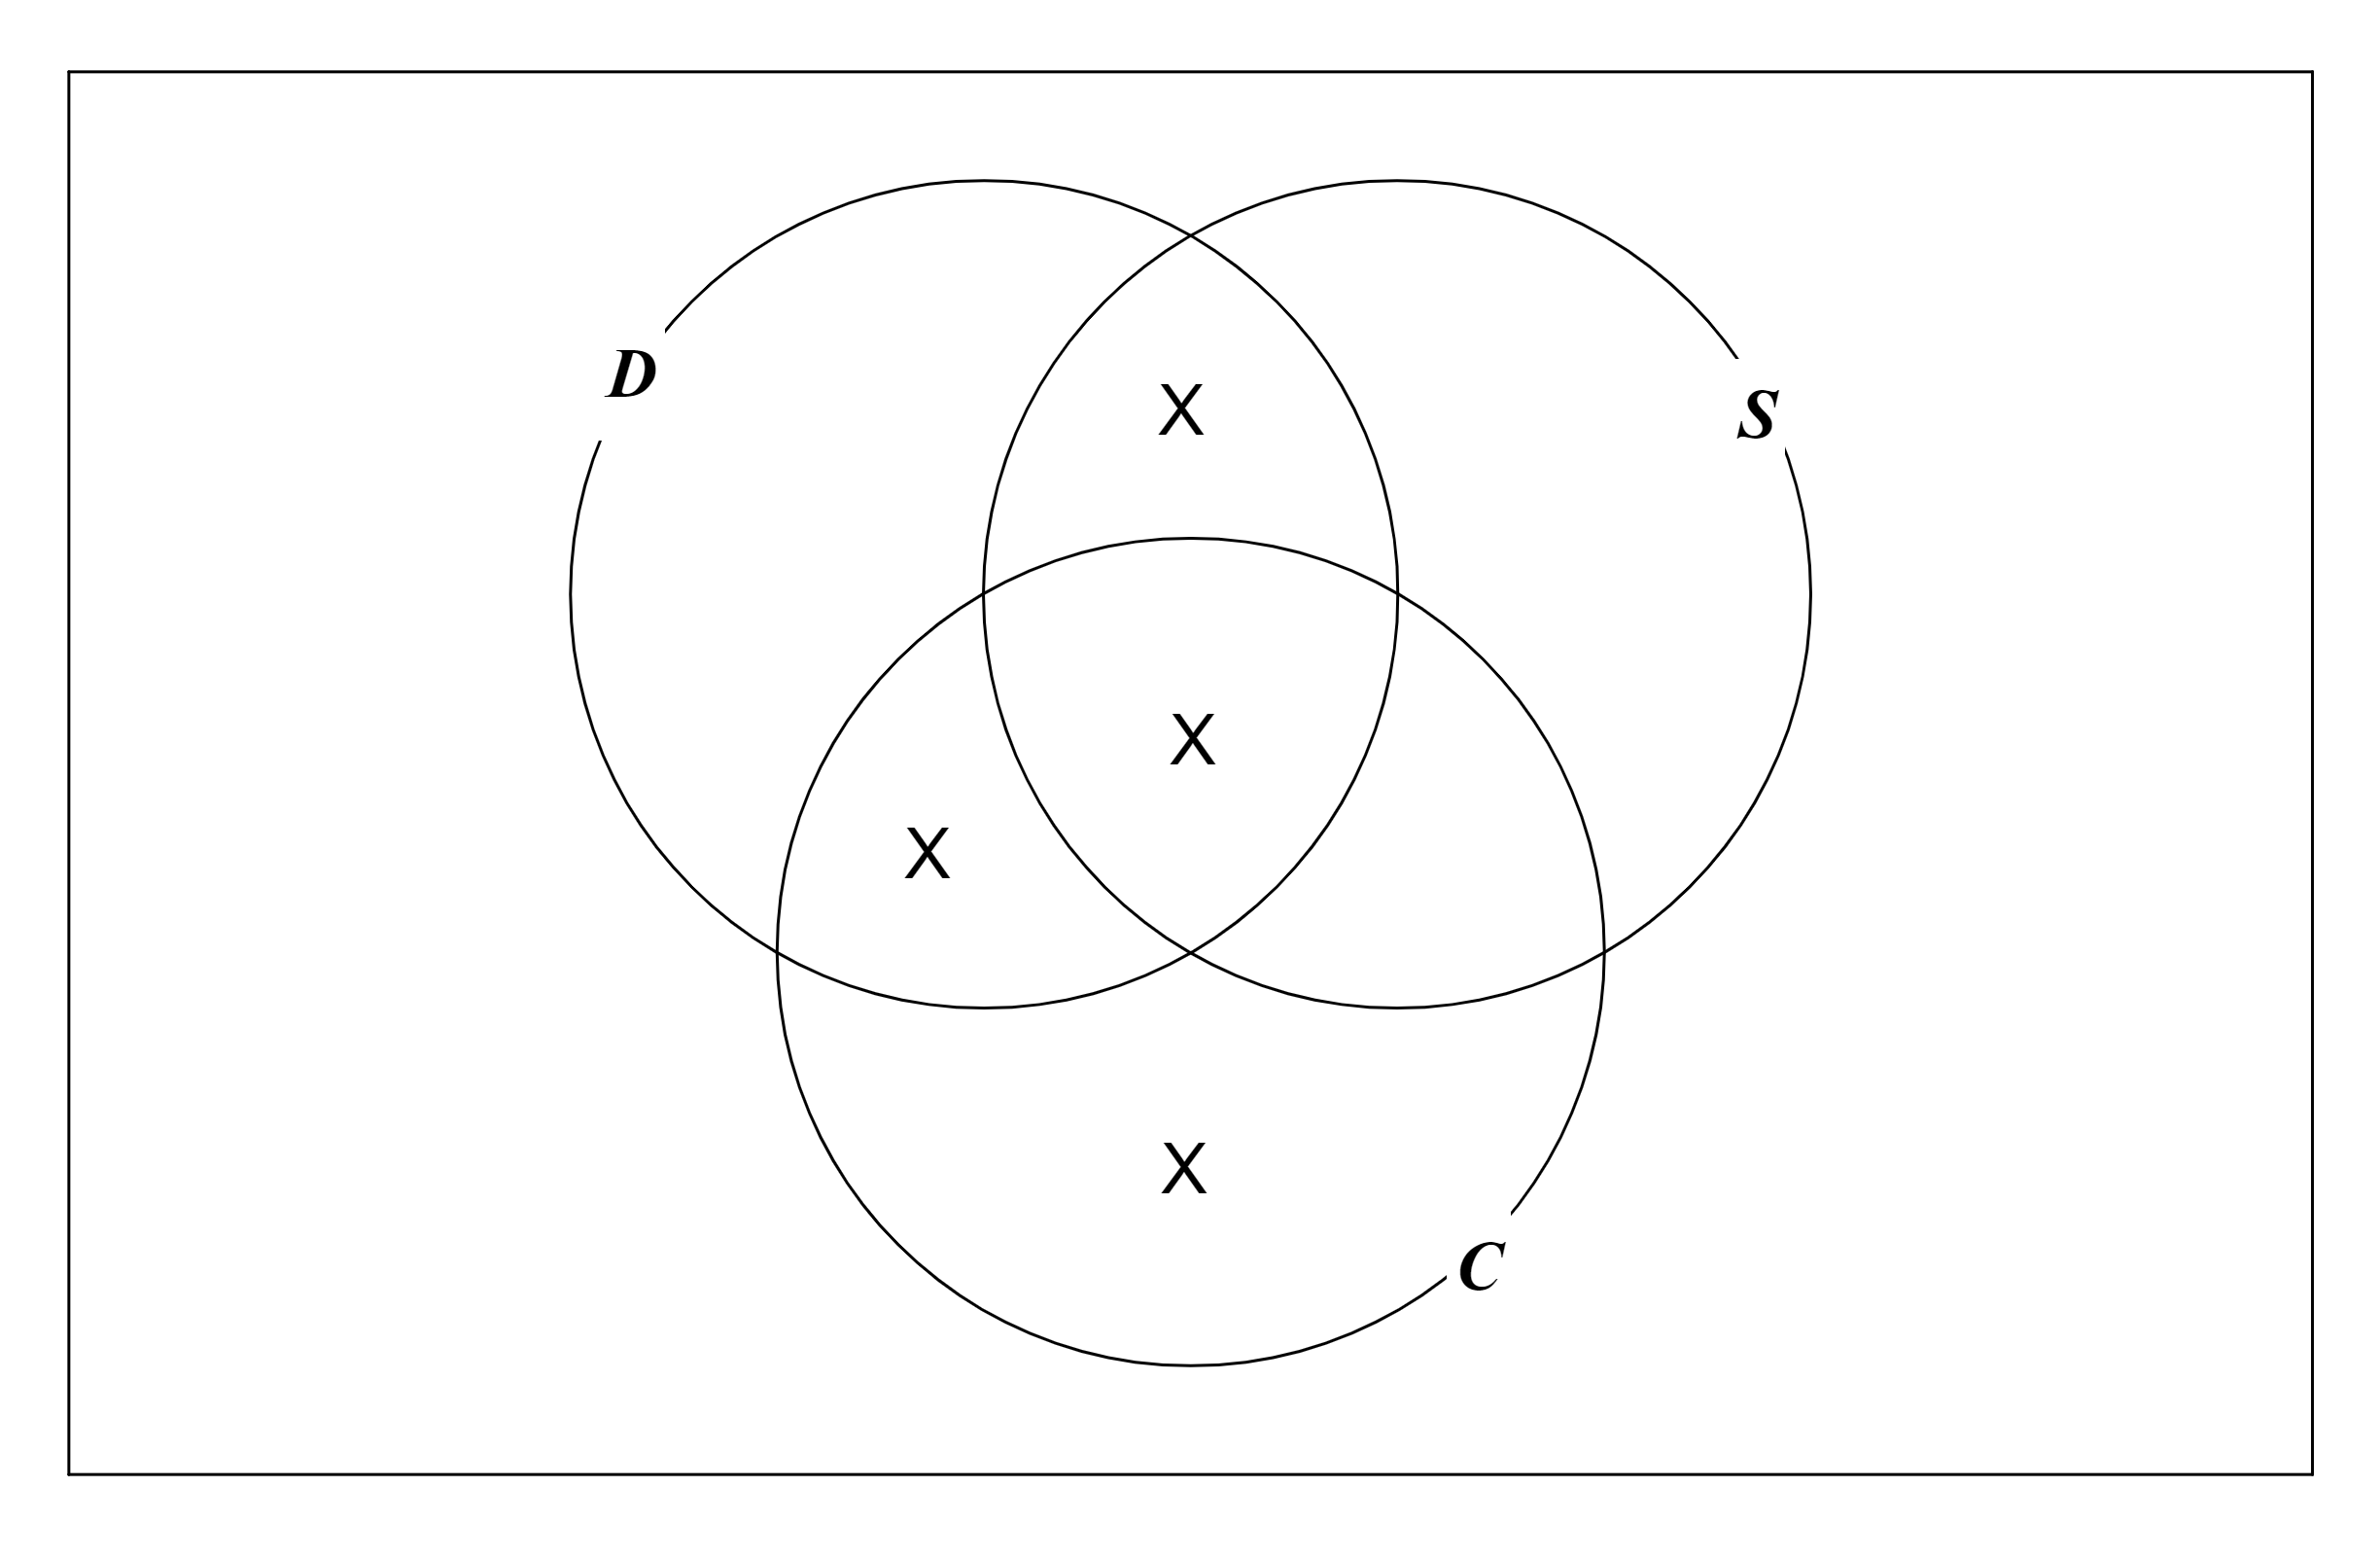

6. valid
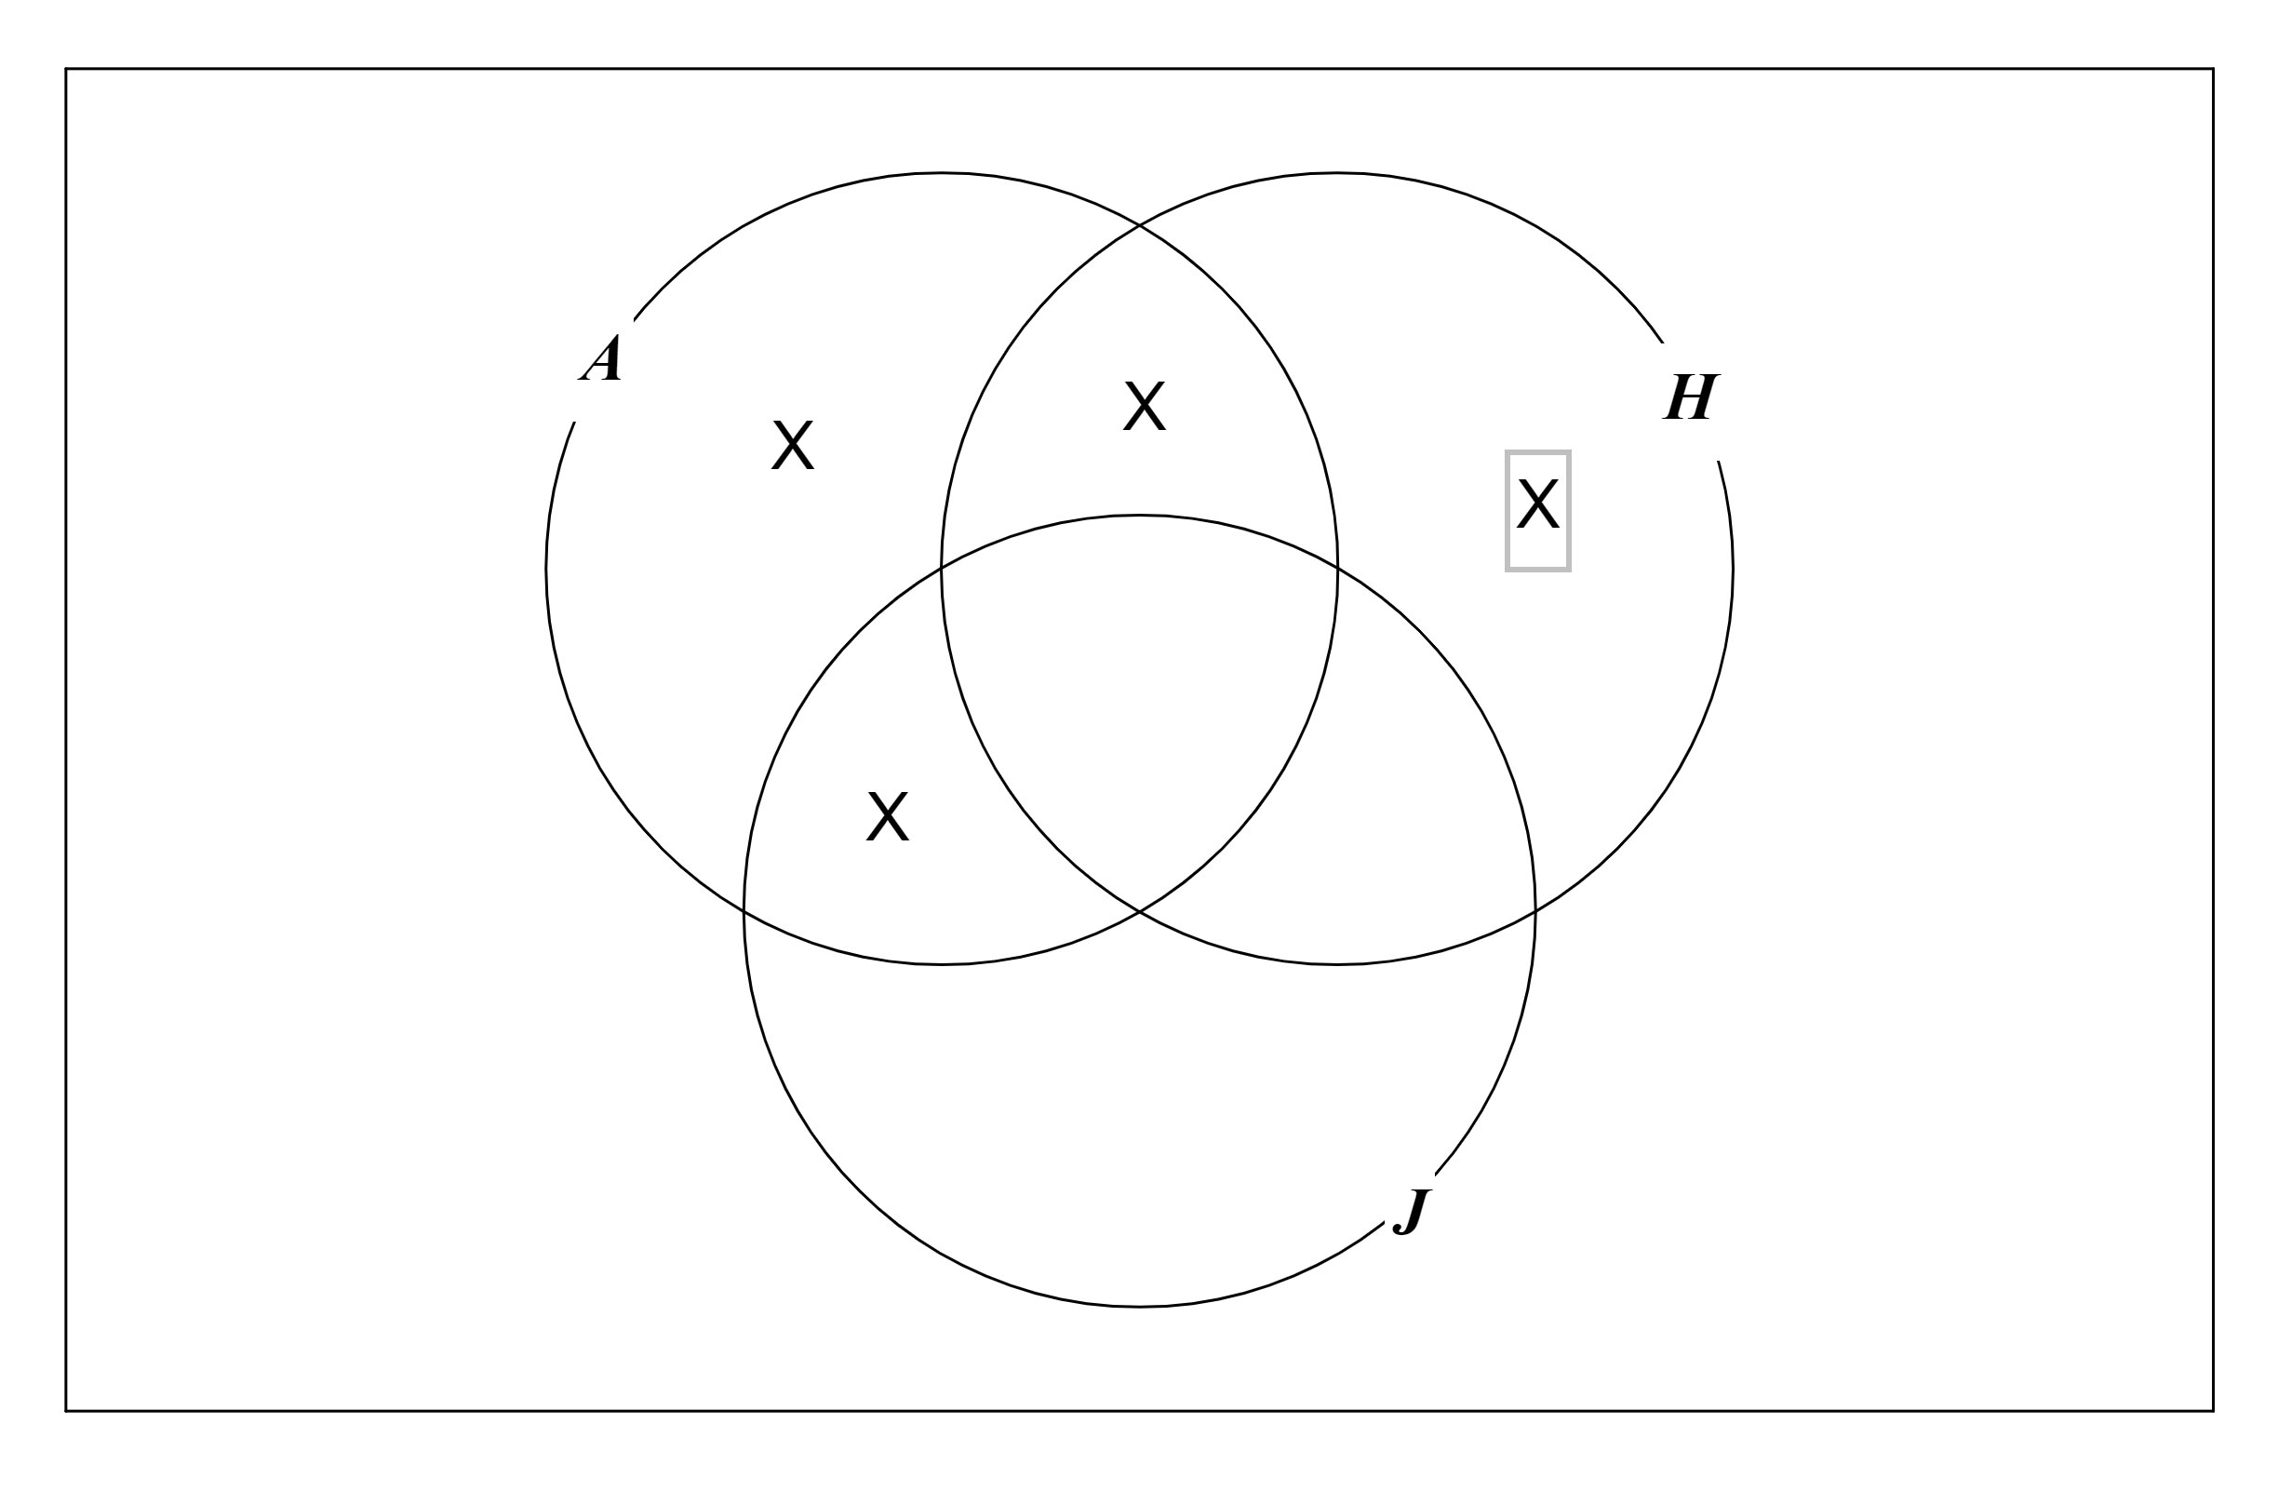

7. valid
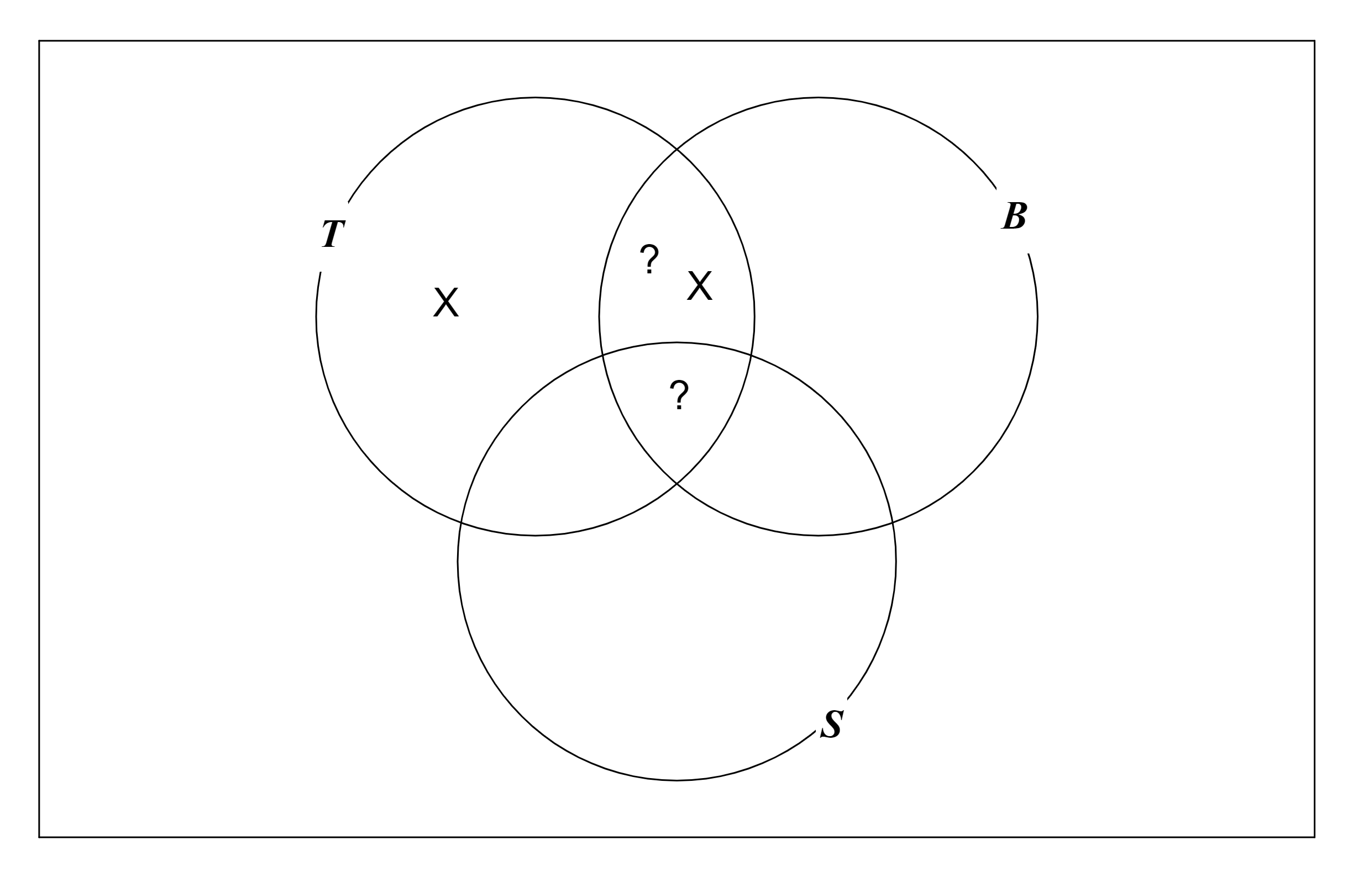

8. invalid
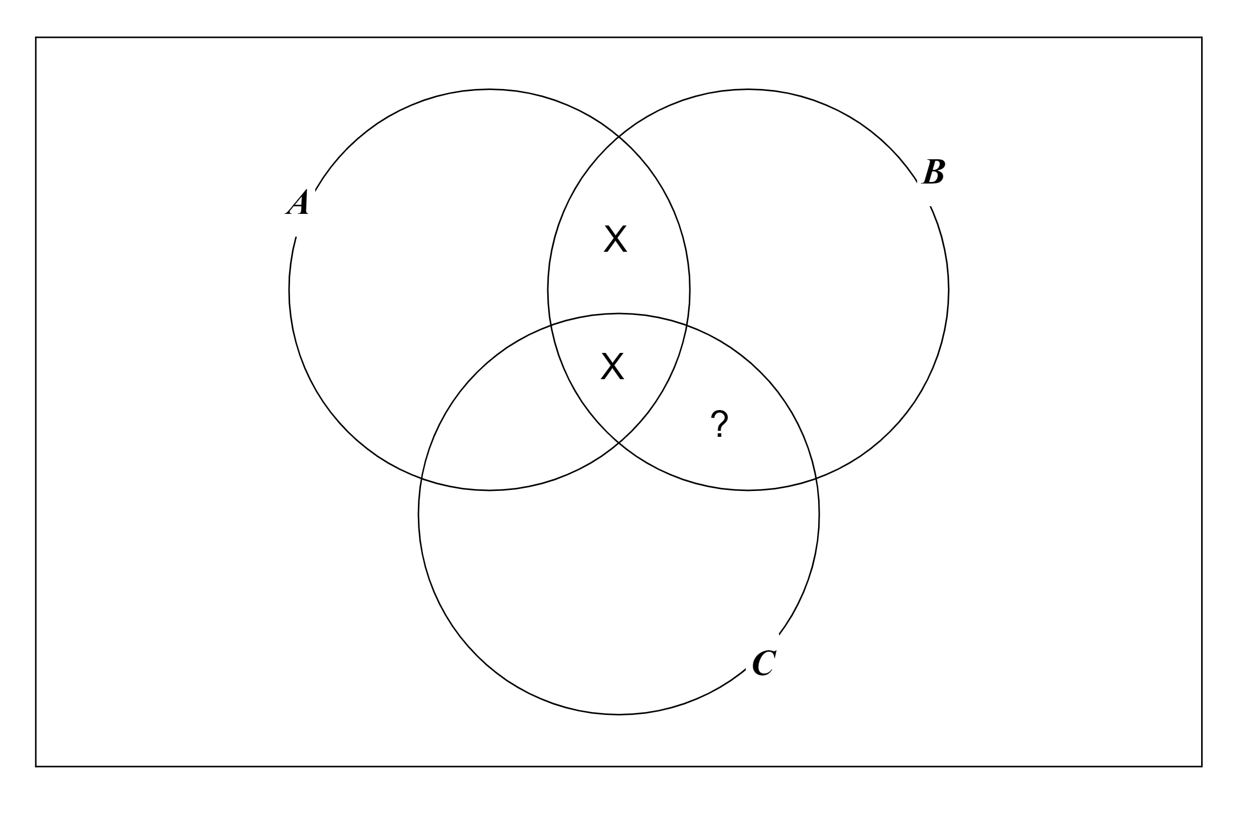

9. invalid
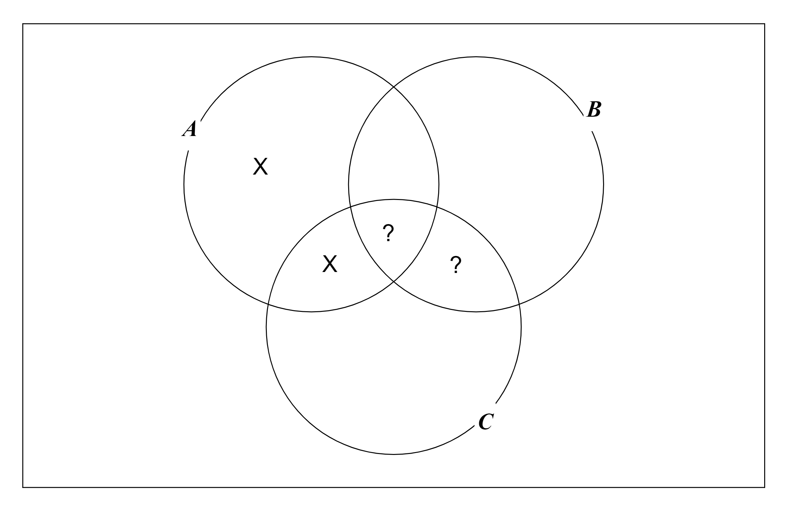

10.
a) Some astronauts do not like jazz
b) Some astronauts like jazz
c) No astronauts like jazz
d) Some A are not B
e) Some A are B
f) Some A are B
g) All A are B

11. Yes

